Estate Sale Jewelry and Waterford Crystal Auction Items List
 | Photo of Item | Description | Estimated Value | Minimum Bid | Buy It Now
 | 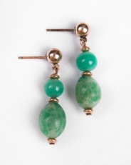 | Green Jade Earrings  10kt gold – contemporary  Stunning Jade Earrings set in 10KT Gold and made in the contemporary style. | $325 | $75 | $175
 | 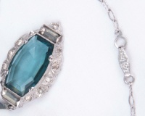 | Crystal Blue Necklace  Aqua blue stone is crystal with a small chip on one corner. It is set in rhodium surrounded by tiny white stones, circa 1920's. | $165 | $55 | $95
 | 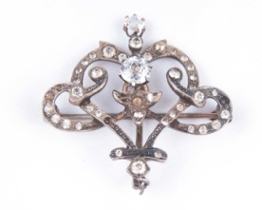 | Austrian Crystal & Sterling Silver Brooch  White diamond-like stones are cut Austrian crystal set in a heart shaped Sterling Silver Pin with pendant loop. Turn of the century. | $165 | $45 | $125
 | 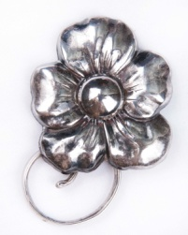 | Sterling Silver Handcrafted Mid 1920-30’s  Mexican Pansie flower pin, circa 1920's, made with Sterling Silver with a repaired pin back. | $85 | $25 | $55
 | 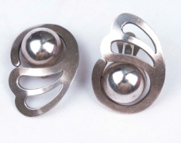 | Mid Century Mexican Earrings  Artisan Made  Sterling silver Mid-Century Mexican Earrings. | $145 | $45 | $95
 | 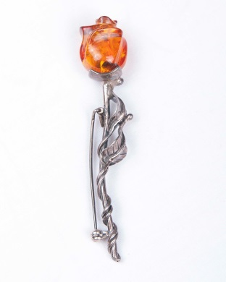 | Vintage Amber Rose, Sterling Pin  Beautiful Vintage Amber Rose Pin set in Sterling Silver. | $135 | $45 | $95
 | 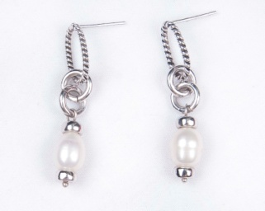 | Contemporary Natural Pearl Earrings  Pearls set in Sterling Silver and made in the contemporary style. | $95 | $25 | $ 65
 | 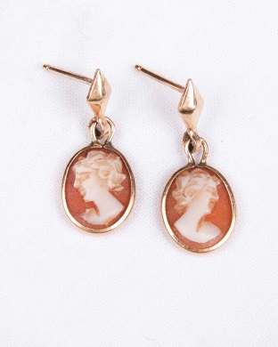 | Coral Cameo, 14KT Gold Earrings  These red earrings are coral carved cameos with backs and bezels set in 14KT Gold; made in ITALY. | $250 | $60 | $175
 | 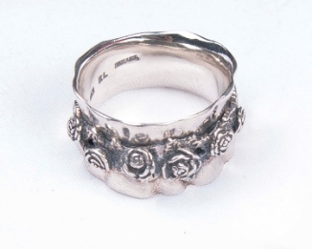 | Sterling Band, Applied Floral Decoration  Small, size 4, Sterling Size Ring made for a petite hand. | $115 | $35 | $ 75
 | 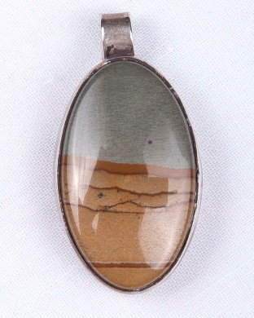 | Agate Sterling Pendant  Agate Stone Set in Sterling Bezel and attached to a Loop. | $185 | $55 | $115
 | 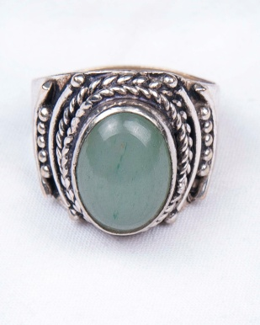 | Green stone Ring  Beautiful Greenstone Ring set in Sterling silver; Size 7. | $85 | $25 | $60
 | 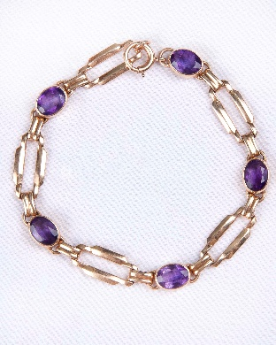 | 14KT Gold Link Bracelet with 5 semi-precious amethyst cut stones  A timeless 14KT Gold Link Bracelet with Semi-Precious Amethyst stones. | $850 | $375 | $675
 | 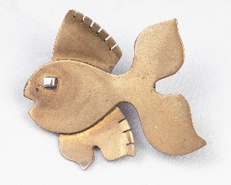 | Mid-Century Artisan Brass Fish Pin  A unique piece that will draw attention from the crowd. | $145 | $35 | $ 75
 | 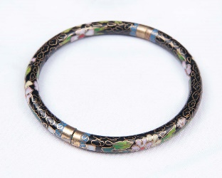 | Vintage Cloisonne Bangle Bracelet  Cloisonne Bangle had inlaid brass wire  design with enamel decoration. | $115 | $30 | $75
 | 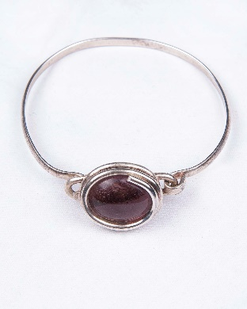 | Mid Century Bangle with Agate  Sterling silver and semi-precious agate stone set in sterling silver bezel with expandable band. | $165 | $45 | $
 | 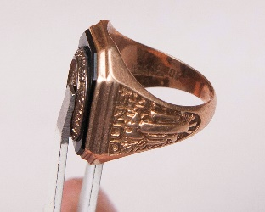 | Gold Class Ring  University of MD 10KT Gold, Onyx Stone class ring , 1961 | $200 | $65 | $175
 | 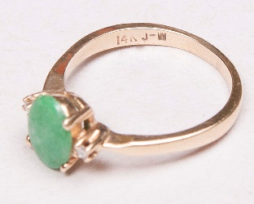 | Gold and Jade Ring  14KT gold and jade ring with diamond chips flanking the center; size small/4. | $850 | $250 | $600
 | 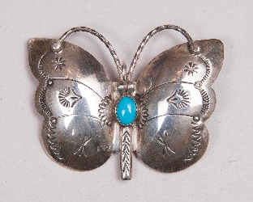 | Mid-century Navajo made sterling silver butterfly pin  Adorned with  Cabochon turquoise center stone; Artist N. Silago. | $165 | $45 | $110
 | 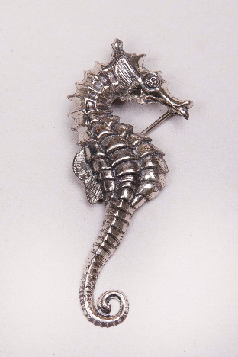 | Mid-century sterling silver seahorse pin  An attention-grabbing pin made by BEAU STERLING. | $75 | $25 | $ 45
 | 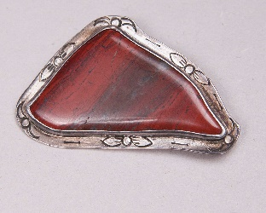 | Artisan made Cinnabar agate Brooch  Brooch set in hand-tooled Sterling Silver Bezel. | $175 | $45 | $125
 | 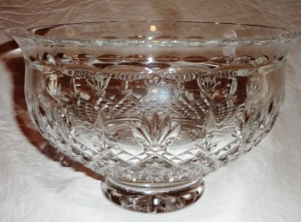 | Waterford Crystal Bowl  A stunning piece to adorn your buffet or server. | $155 | $55 | $115
 | 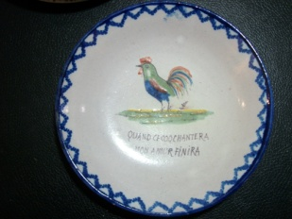 | Quimper Plate from France  Plate is Quimper and made in France in the 1800's. | $100 | $35 | $85
 | 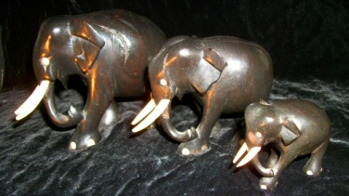 | Ebony African Elephants  African Ebony Elephants made in the contemporary style.Sset of 3 with 2 bookends. | $350 | $75 | $250
 | 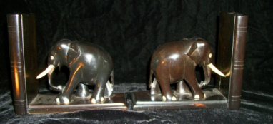 | Same as above |  |  | $
 | 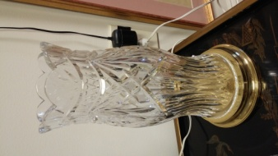 | Waterford Irish Crystal Hurricane Lamp with Brass Candle Stick  A timeless piece to adorn your end table or server. | $275 | $65 | $165
 | 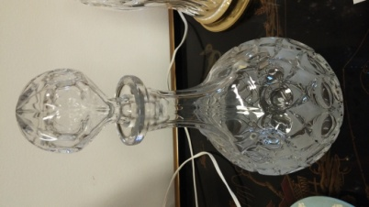 | Austrian Crystal Decanter  Decanter will be a welcomed addition to your whiskey closet or bar. | $165 | $55 | $115
 | 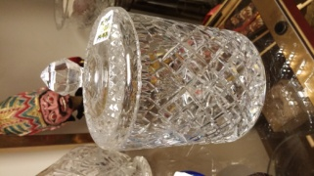 | Waterford Irish Crystal Cookie Jar  A practical and beautiful piece to add to your collection. | $350 | $85 | $215
 | 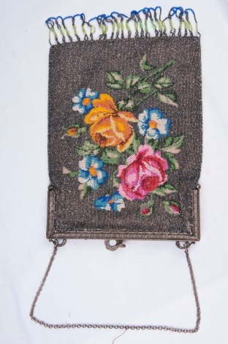 | Ladies’ Floral Beaded Handbag  1920’s Handmade Handbag with Sterling Chain beaded with flower design in multi -color, silver ground and fringe. | $350 | $55 | $255
 | 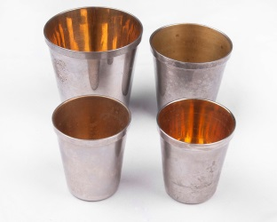 | Graduated Set of Silver and Gold Plated Shot Cups  Silver and Gold Plate Shot cups are German made and a talking piece. | $125 | $35 | $65
 | 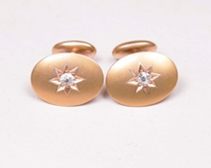 | 14KT Gold w/Diamond Star, Antique MASONIC, Cufflinks, 1897  Stunning Masonica Cufflinks made in the late 1800’s. | $750 | $450 | $600
 | 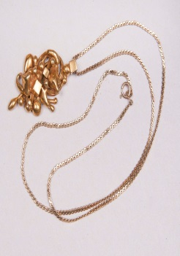 | Mid Century Artisan made Gold Fill Sculptural Pendant, Chain not included  Gold Fill Sculptural Pendant will add charm and class to any outfit. | $125 | $35 | $95
 |  |  | $ | $ | $
 |  |  | $ | $ | $
 |  |  | $ | $ | $
 |  |  | $ | $ | $
 | TOTAL of Minimum Bid Merchandise |  |  | $
(Example of Individual Bid Sheet)

Coral Cameo Earrings
Estimated Value:

Bidding Starts @ $45.00
*Must increase each bid by $5*
 | Name | Bid Amount

Waterford Irish Crystal Cookie Jar
Estimated Value: $350 |  | Minimum Bid: $115
 | Beautiful Waterford Irish Crystal Cookie Jar with Ornate Lid to Adorn Your Server or Buffet Table.

Bidding Starts @ $115.00
*Must increase each bid by $5*
 | Name | Bid Amount

Antique Decanter
Estimated Value: $215 |  | Minimum Bid: $95.00
 | Beautiful Antique Decanter with Globe-Shaped Stopper to Adorn Your Gentleman’s Pantry or Bar Top.

Bidding Starts @ $95.00
*Must increase each bid by $5*
 | Name | Bid Amount

Waterford Irish Crystal Candle Holder
Estimated Value: $350 |  | Minimum Bid: $115.00
 | Beautiful Waterford Irish Crystal Candle Holder with Golden Stand to Adorn Your End Table, China Cabinet, or Sitting Room.

Bidding Starts @ $115.00
*Must increase each bid by $5*
 | Name | Bid Amount

Ebony African Elephant Trio
Estimated Value: $250 |  | Minimum Bid: $75.00
 | Contemporary African Elephant Trio Sculpture featuring a Family of African Elephants.

Bidding Starts @ $75.00
*Must increase each bid by $5*
 | Name | Bid Amount

Ebony African Elephant Bookends
Estimated Value: $250 |  | Minimum Bid: $75.00
 | Contemporary Ebony African Elephant Bookends to Adorn Your Library or Office Space.

Bidding Starts @ $75.00
*Must increase each bid by $5*
 | Name | Bid Amount

French Quimper Plate
Estimated Value: $100 |  | Minimum Bid: $45.00
 | This Ornate Quimper Plate was made in France in the 1800’s. It will bring charm and character to your kitchen or country home.

Bidding Starts @ $45.00
*Must raise each bid by minimum of $5*
 | Name | Bid Amount

Coral Cameo Earrings
Estimated Value: $135 |  | Minimum Bid: $65.00
 | Beautiful Waterford Irish Crystal Bowl to adorn you Buffet Server or China Cabinet.

Bidding Starts @ $65.00
*Must raise bid by minimum of $5*
 | Name | Bid Amount

Greenstone Ring
Estimated Value: $85 |  | Minimum Bid: $40.00
 | Greenstone Ring in Sterling Silver will have your friends green with envy.

Bidding Starts @ $40.00
*Must increase bid by minimum of $5*
 | Name | Bid Amount

Filigreed Sterling Silver Ring
Estimated Value: $145 |  | Minimum Bid: $45.00
 | Filigreed Sterling Silver Ring to adorn a petite hand. Size 4.

Bidding Starts @ $45.00
*Must raise bid by a minimum of $5*
 | Name | Bid Amount

Contemporary Pearl Earrings
Estimated Value: $85 |  | Minimum Bid: $40.00
 | Contemporary Pearl Earrings will bring both flair and class to your style.

Bidding Starts @ $40.00
*Must increase bid by minimum of $5*
 | Name | Bid Amount

Contemporary Pendant
Estimated Value: $65 |  | Minimum Bid: $25.00
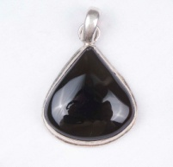 | Contemporary Brown-Stone Pendant set in Sterling Bezel. Full of character and charisma to decorate your attire.

Bidding Starts @ $25.00
*Must raise each bid by $5*
 | Name | Bid Amount

Mexican Earrigns
Estimated Value: $145 |  | Minimum Bid: 50.00
 | Authentic Mexican Earrings made from Sterling Silver will add spark and intrigue to your outfit.

Bidding Starts @ $50.00
*Must increase bid by minimum of $5*
 | Name | Bid Amount

Mid-Century Mexican Flower Pin
Estimated Value: $125 |  | Minimum Bid: $35.00
 | Stemming for the 1920s, this Mid-Century Mexican Flower Pin will draw the attention of any onlooker.

Bidding Starts @ $45.00
*Must increase bid by minimum of $5*
 | Name | Bid Amount

Austrian Brooch
Estimated Value: $150 |  | Minimum Bid: $60.00
 | Vintage Austrian Brooch hosts a White-Stone Crystal and is set in Sterling Silver. It was made in the early 1900’s.

Bidding Starts @ $60.00
*Must increase bid by minimum of $5*
 | Name | Bid Amount

Blue Crystal Necklace
Estimated Value: $135 |  | Minimum Bid: $50.00
 | Created in the 1920’s, this Crystal Blue Necklace is simple yet elegant and screams Gatsby.

Bidding Starts @ $45.00
*Must increase bid by minimum of $5*
 | Name | Bid Amount

Green Jade Earrings
Estimated Value: $175 |  | Minimum Bid: $45.00
 | Tantalizing Green Jade Earrings set in 14K Gold are Contemporary in Style and will make you the talk of the party.

Bidding Starts @ $45.00
*Must increase bid by minimum of $5*
 | Name | Bid Amount

Cross Pendant and Chain
Estimated Value: $65 |  | Minimum Bid: $25.00
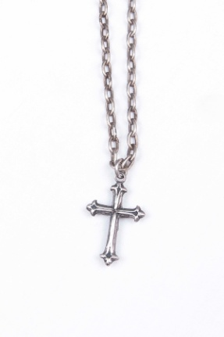 | Cross Pendant and Chain is Simple and Ornate at the same time.

Bidding Starts @ $45.00
*Must increase bid by minimum of $5*
 | Name | Bid Amount

